# Personal Portfolio Submission

## WEBD152 - Beginning Web Development

<https://ashleywong9398.github.io/WEBD152/week2/homework.html>

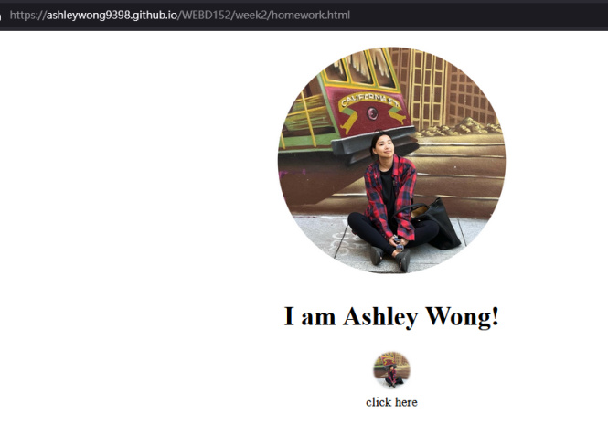

<https://ashleywong9398.github.io/WEBD152/week3/Assignment2.html>

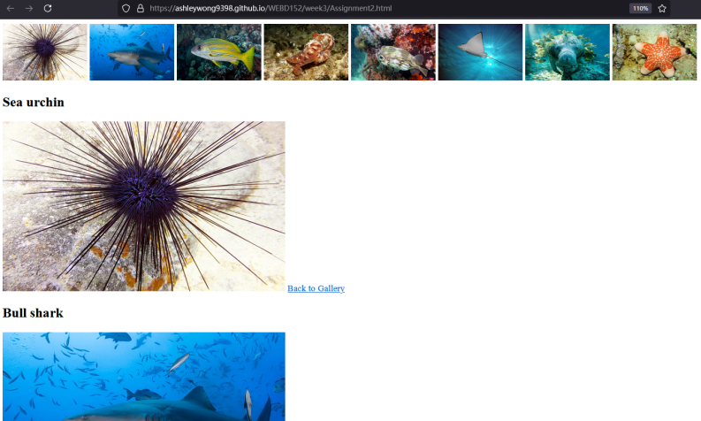

<https://ashleywong9398.github.io/WEBD152/week4/Assignment3.html>

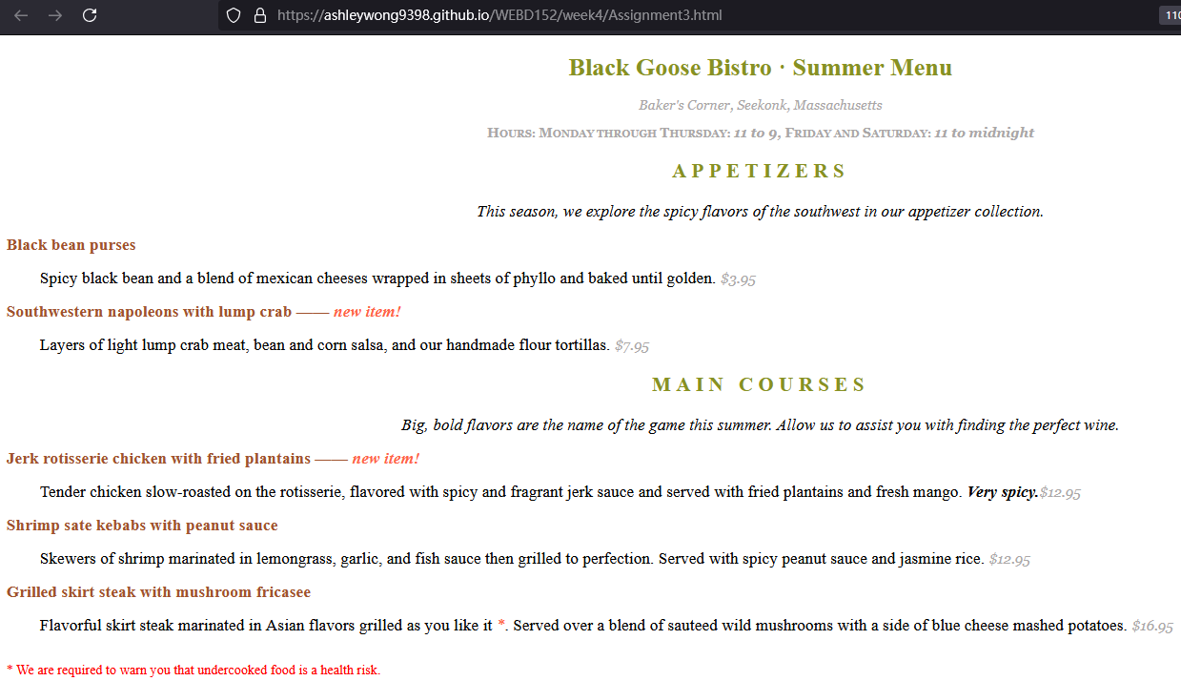

<https://ashleywong9398.github.io/WEBD152/week5/Assignment4.html>

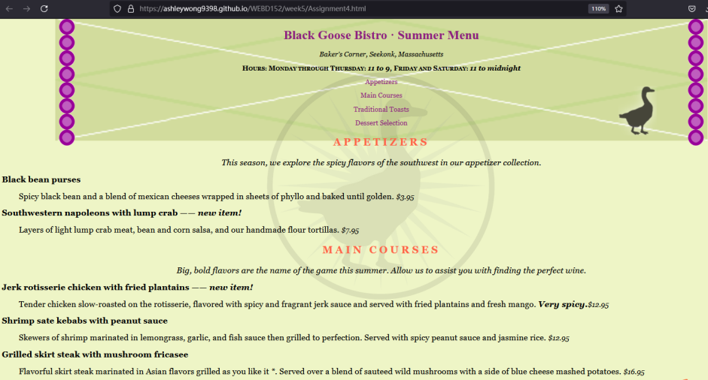

<https://ashleywong9398.github.io/WEBD152/week6/burgerbuild.html>

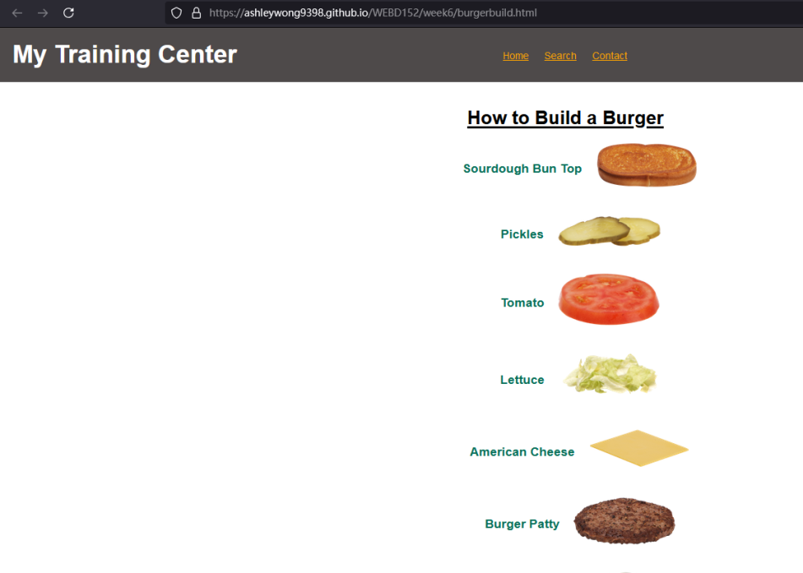

<https://ashleywong9398.github.io/WEBD152/structure/homepage.html>

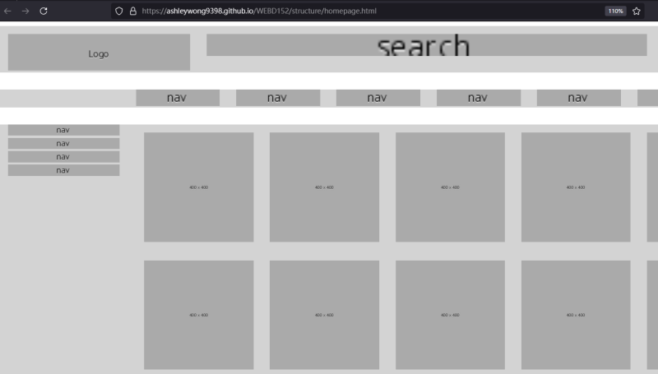

<https://ashleywong9398.github.io/WEBD152/sharing.com/homepage.html>

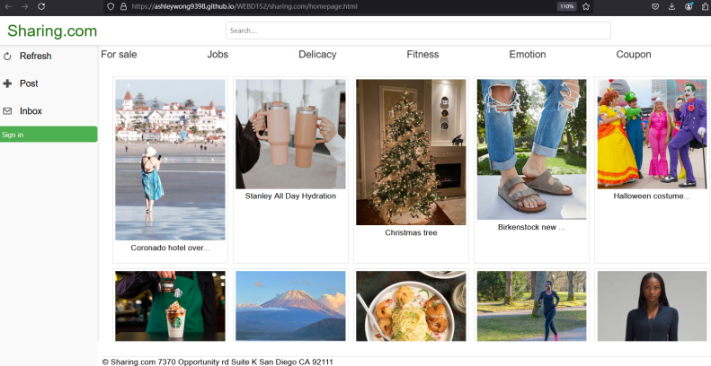

<https://ashleywong9398.github.io/WEBD152/FinalProjectSharing>

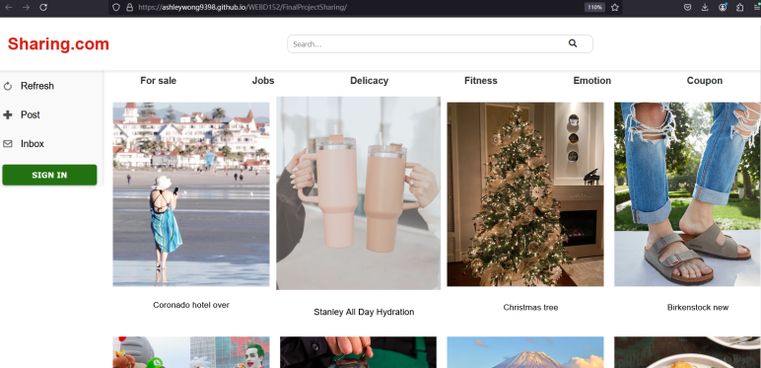

<https://ashleywong9398.github.io/WEBD152/FinalProjectAshley/FinalProjectAssignment.html>

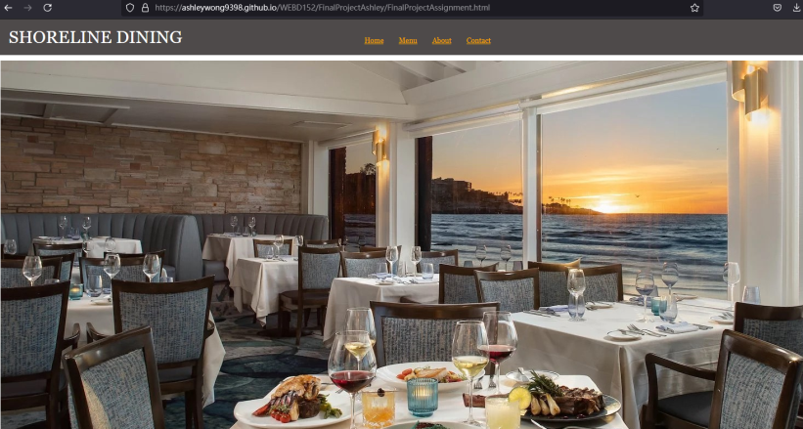

## WEBD164 - Javascript Fundamentals for Web Development

<https://ashleywong9398.github.io/WEBD164/week1/Homework1.html>

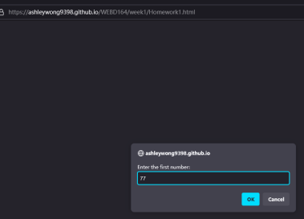 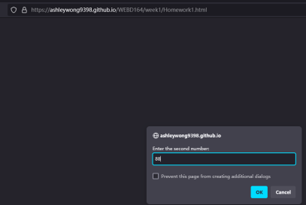

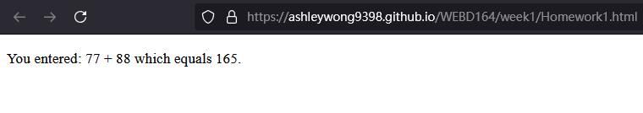

<https://ashleywong9398.github.io/WEBD164/week3/Homework2.html>

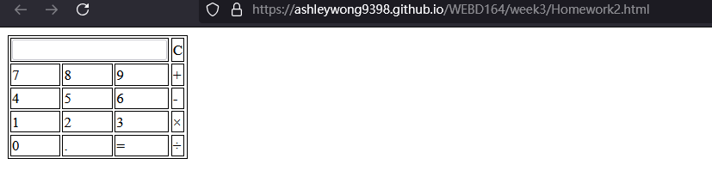

<https://ashleywong9398.github.io/WEBD164/week4/Homework3.html>

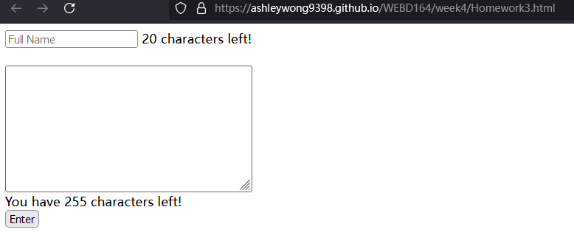

<https://ashleywong9398.github.io/WEBD164/week6/Homework4.html>

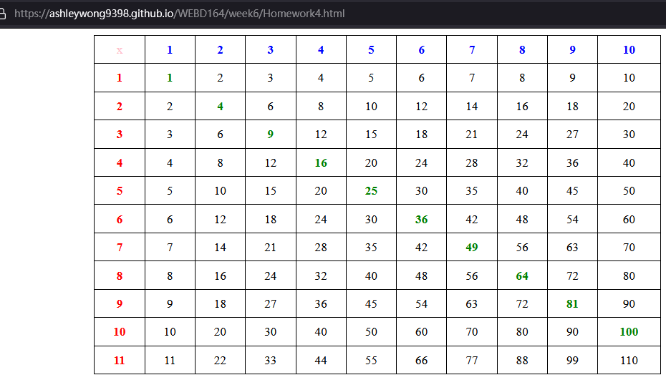

<https://ashleywong9398.github.io/WEBD164/week9/Homework5.html>

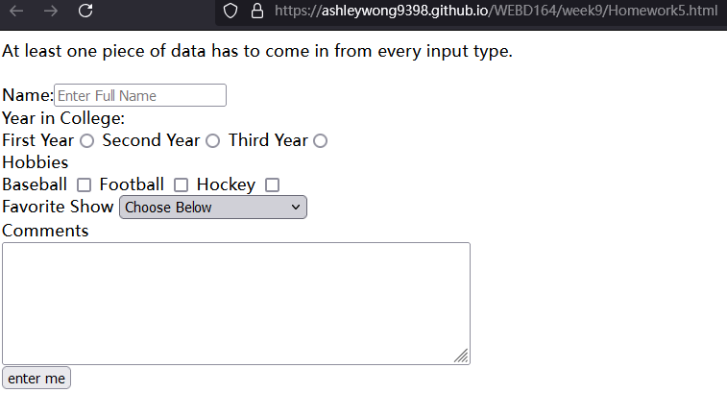

<https://ashleywong9398.github.io/WEBD164/week12/Homework6.html>

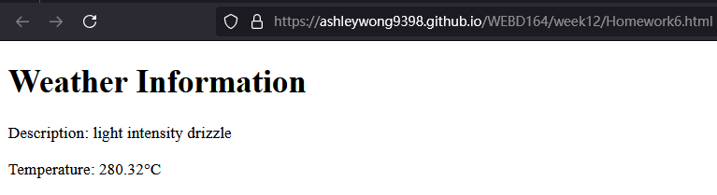

<https://ashleywong9398.github.io/WEBD164/week12/weather.html>

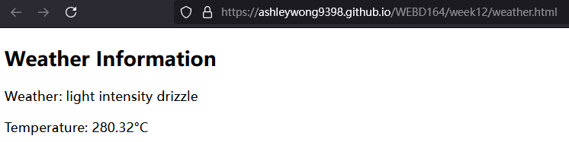

<https://ashleywong9398.github.io/WEBD164/finalproject>

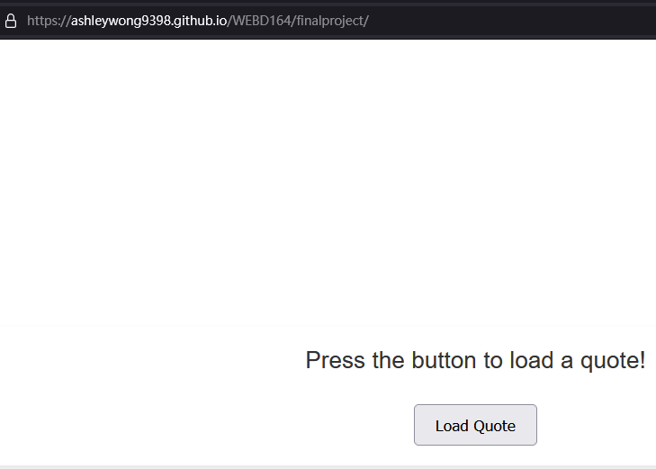

## WEBD168 - Intermediate HTML (HyperText Markup Language) and CSS (Cascading Style Sheets) for Web Design

<https://ashleywong9398.github.io/WEBD168/lesson01/bio.html>

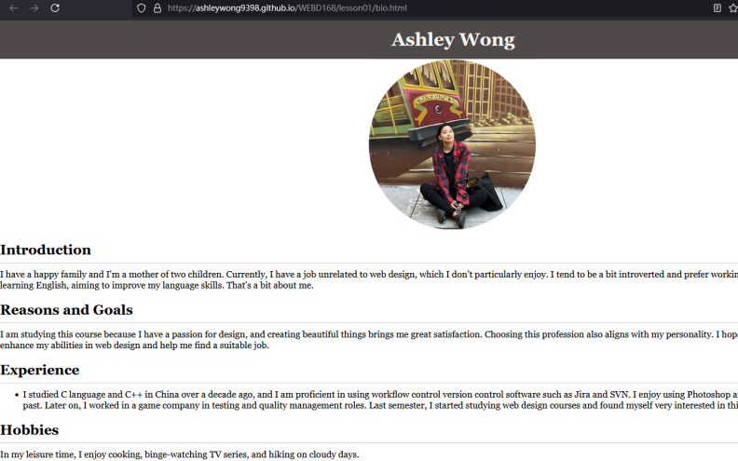

<https://ashleywong9398.github.io/WEBD168/lesson02/selector_basics_start.html>

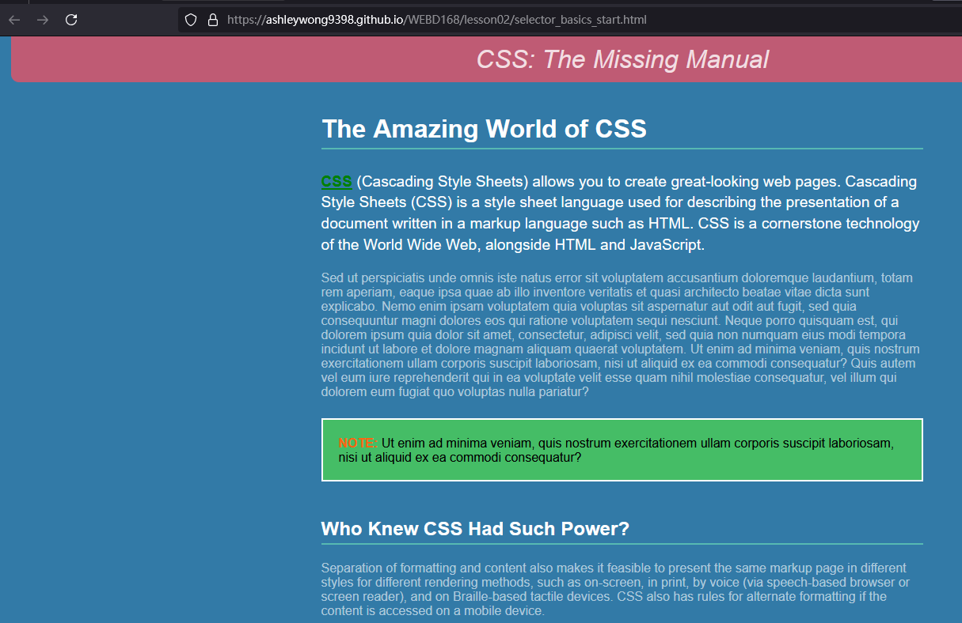

<https://ashleywong9398.github.io/WEBD168/lesson03/03_box_model_complete.html>

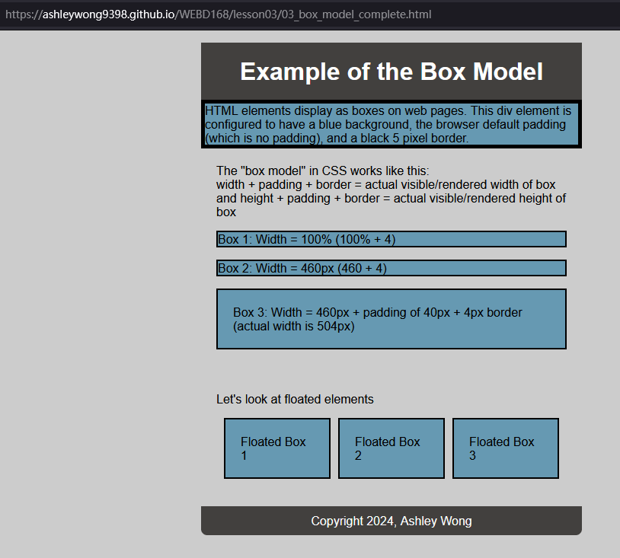

<https://ashleywong9398.github.io/WEBD168/lesson04/04_web_typography.html>

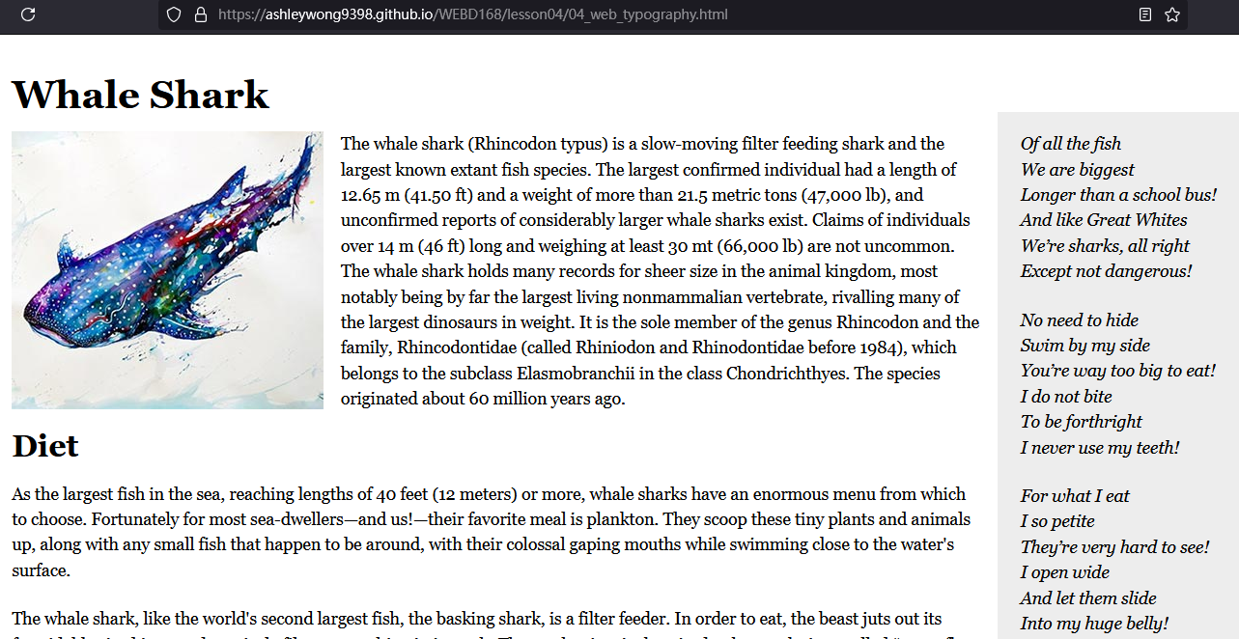

<https://ashleywong9398.github.io/WEBD168/lesson05/04_multiple_bgs.html>

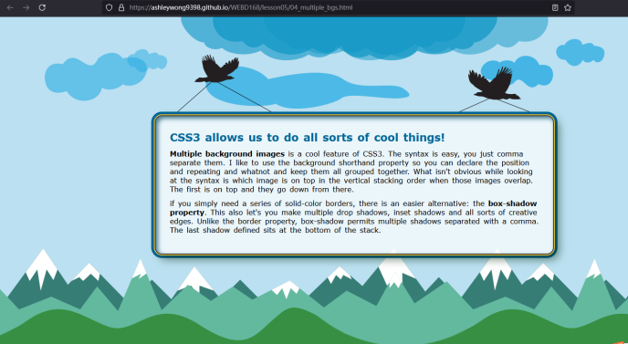

<https://ashleywong9398.github.io/WEBD168/lesson05/05_box_shadow.html>

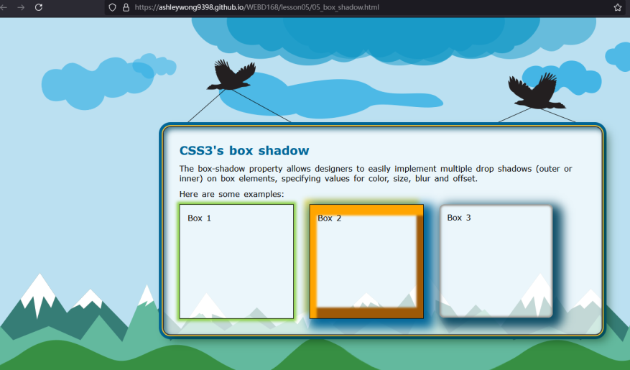

<https://ashleywong9398.github.io/WEBD168/lesson06>

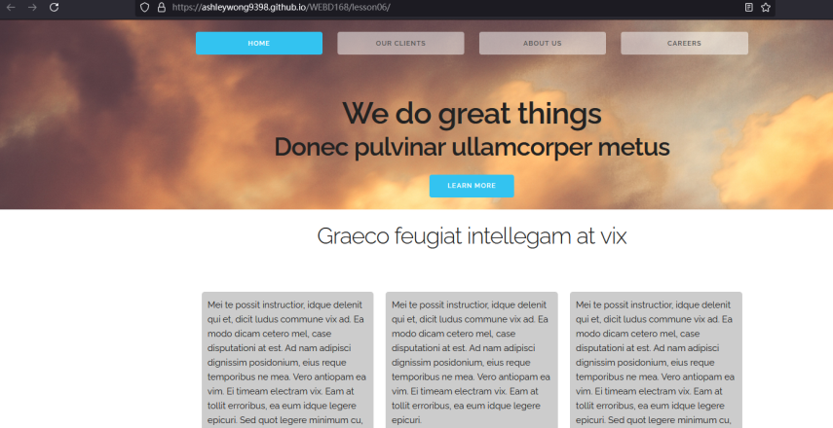

<https://ashleywong9398.github.io/WEBD168/lesson07/ch07_assignment>

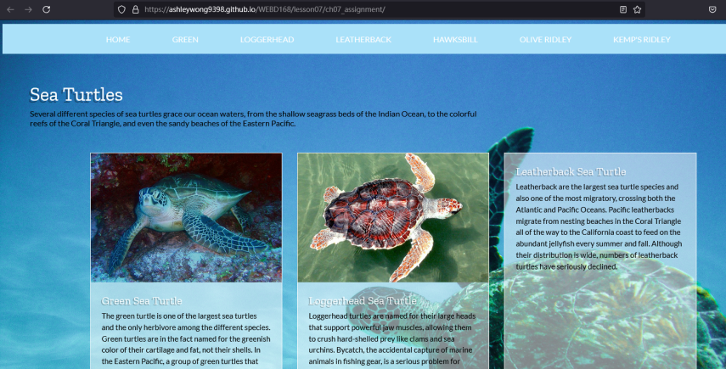

<https://ashleywong9398.github.io/WEBD168/lesson07/testimonials-grid-section>

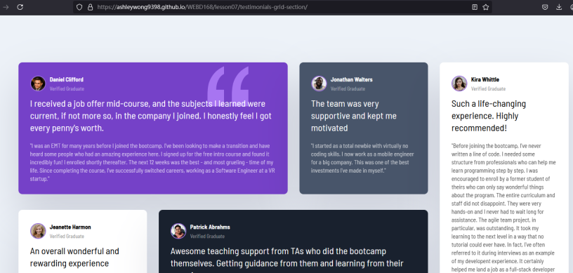

<https://ashleywong9398.github.io/WEBD168/lesson08/ch08_assignment/whaleShark.html>

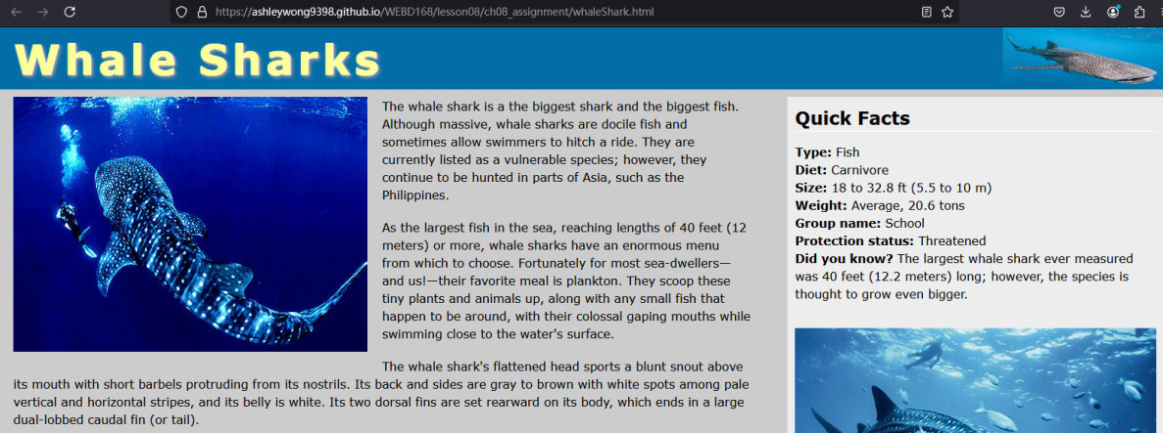

<https://ashleywong9398.github.io/WEBD168/lesson08/skeleton-grid-system>

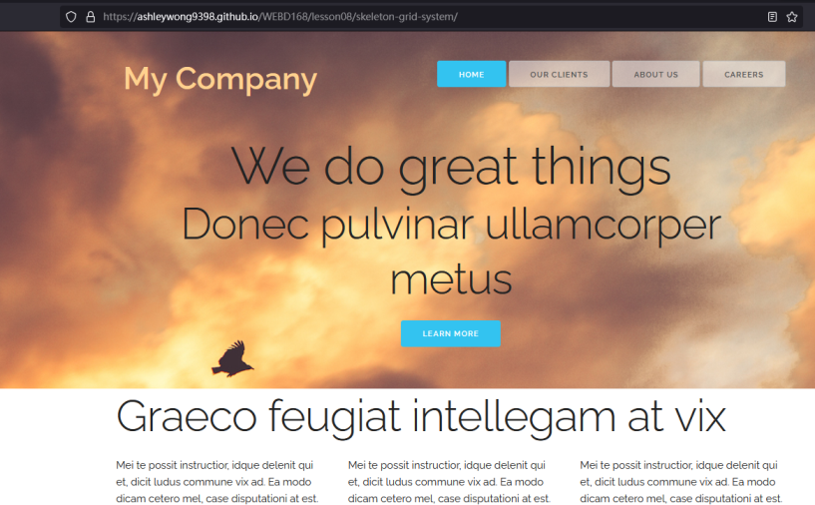

<https://ashleywong9398.github.io/WEBD168/lesson09/09_bootstrap>

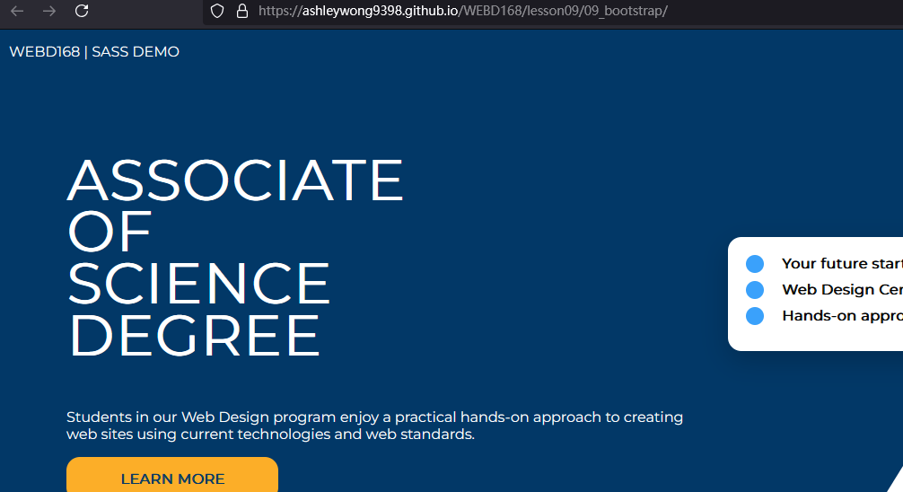

<https://ashleywong9398.github.io/WEBD168/lesson09/starter-theme>

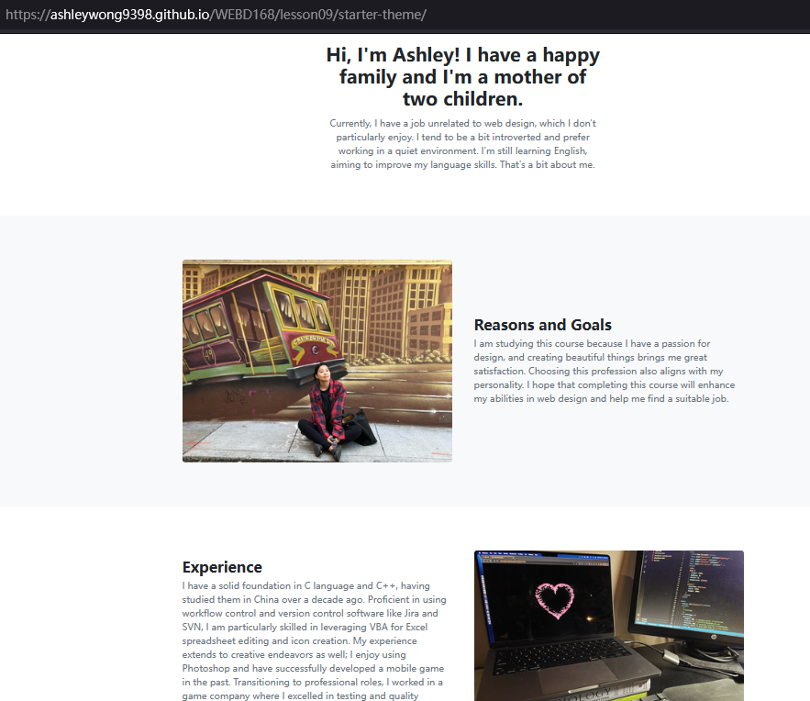

<https://ashleywong9398.github.io/WEBD168/lesson10/bio.html>

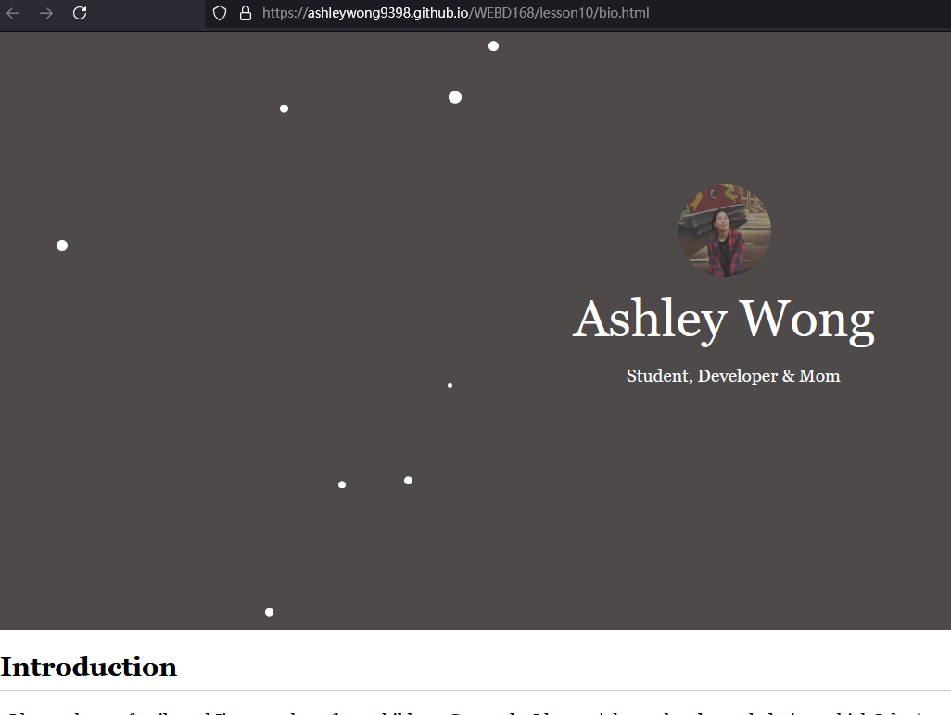

<https://ashleywong9398.github.io/WEBD168/lesson11>

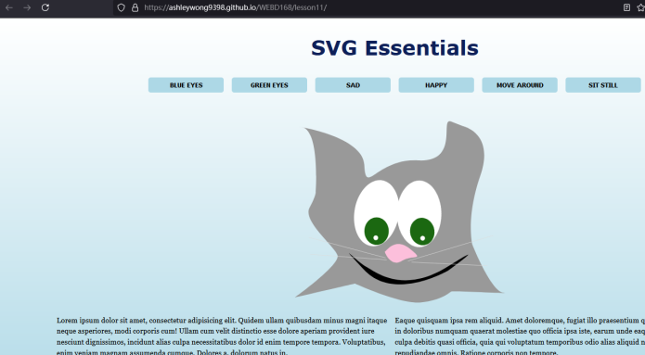

<https://ashleywong9398.github.io/WEBD168/final/>

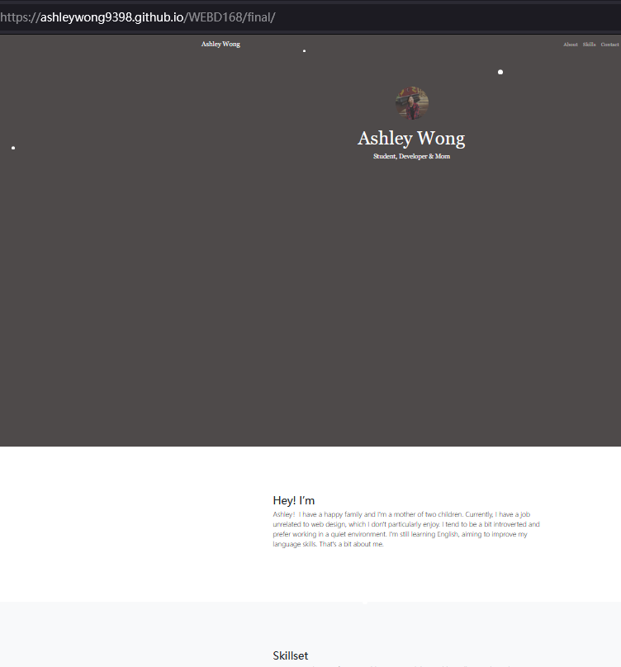

## WEBD171 - Advanced Javascript for Web Development

## <https://ashleywong9398.github.io/WEBD171/week1/Assignment1.html>

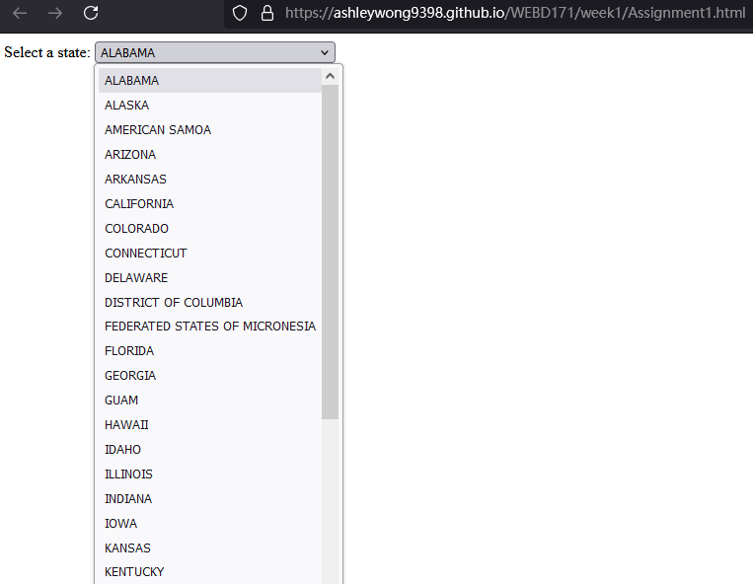

<https://ashleywong9398.github.io/WEBD171/week2/bootstrap5-1.html>

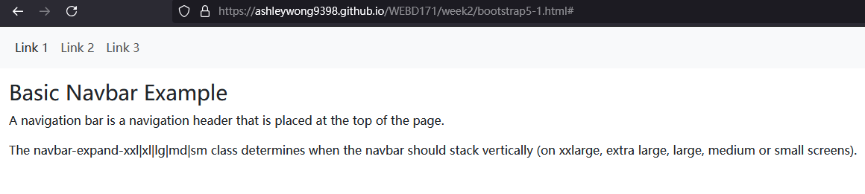

<https://darling-kleicha-77c66b.netlify.app/>

